USER MANUAL:

1. 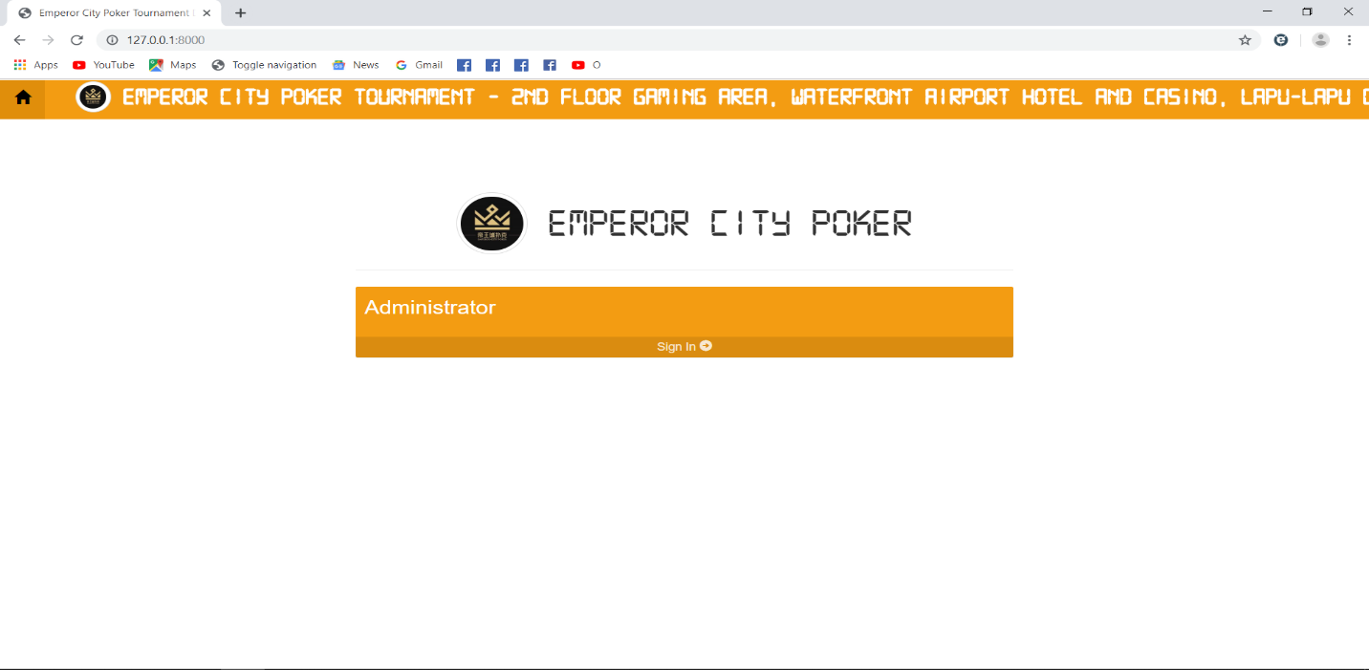Welcome Page
2. 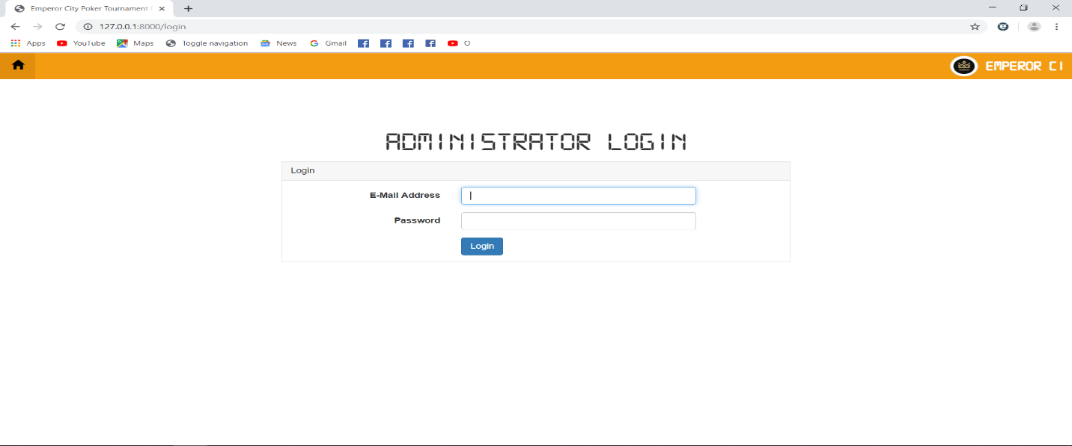Login Page
3. 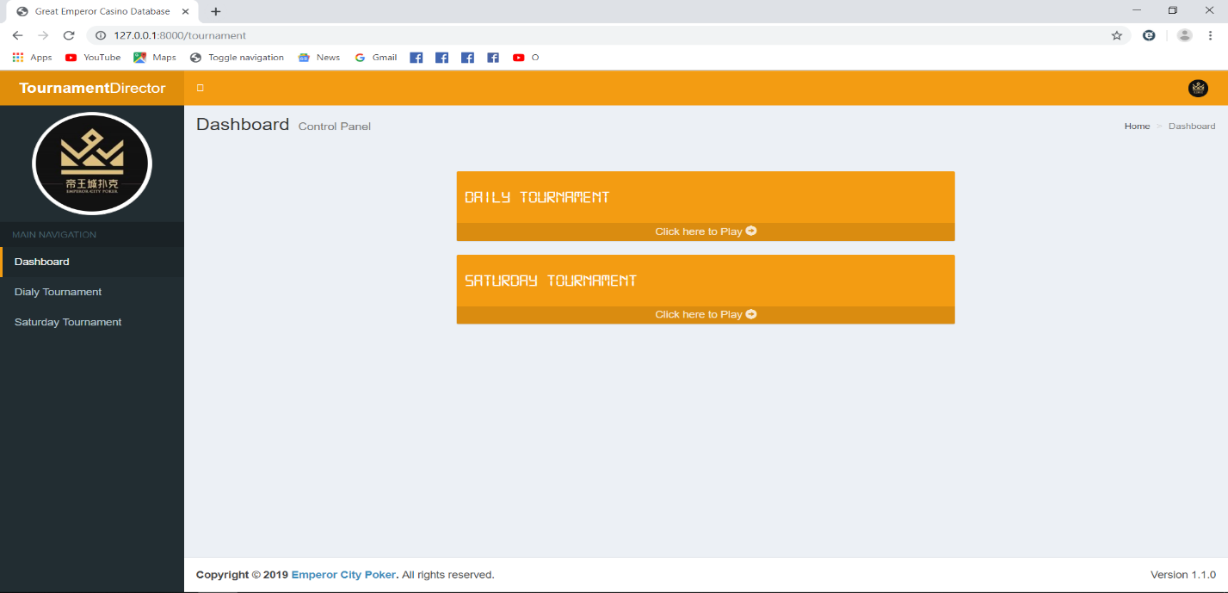Dashboard
4. Daily Tournament
5. 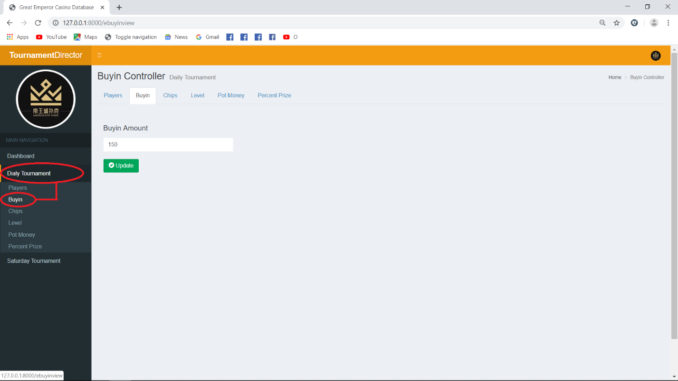Set the Buyin Amount: Under Main Navigation, click “Daily Tournament” and click “Buyin”. Then input the desired amount and click “Update” button. A success message will appear once it is successfully updated. Kindly refer to the images bellow.

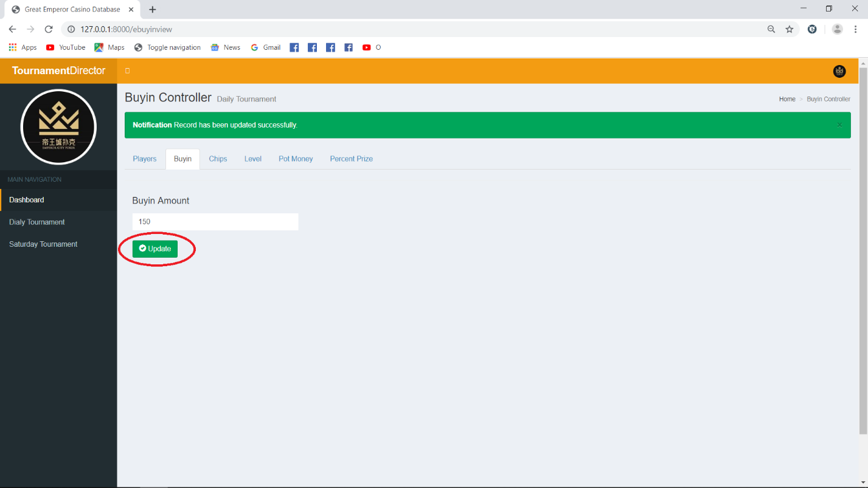

1. 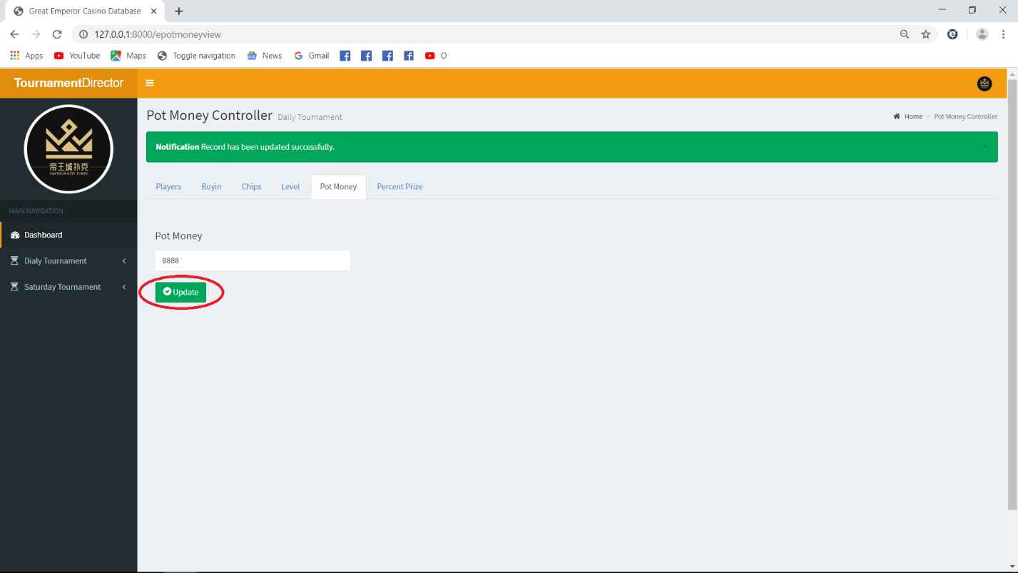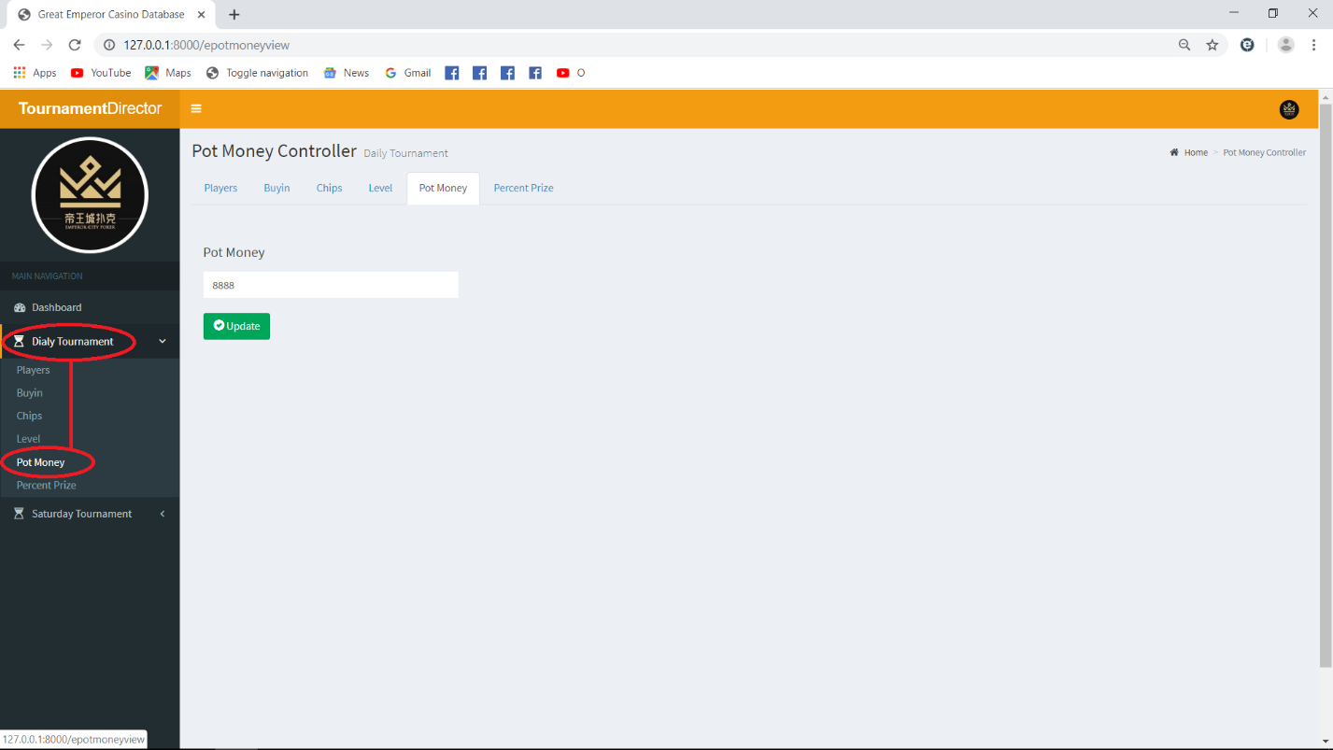Set Pot Money: Under Main Navigation, click “Daily Tournament” and click “Pot Money”. Then input the desired amount and click “Update” button. A success message will appear once it is successfully updated. Kindly refer to the images bellow.
2. 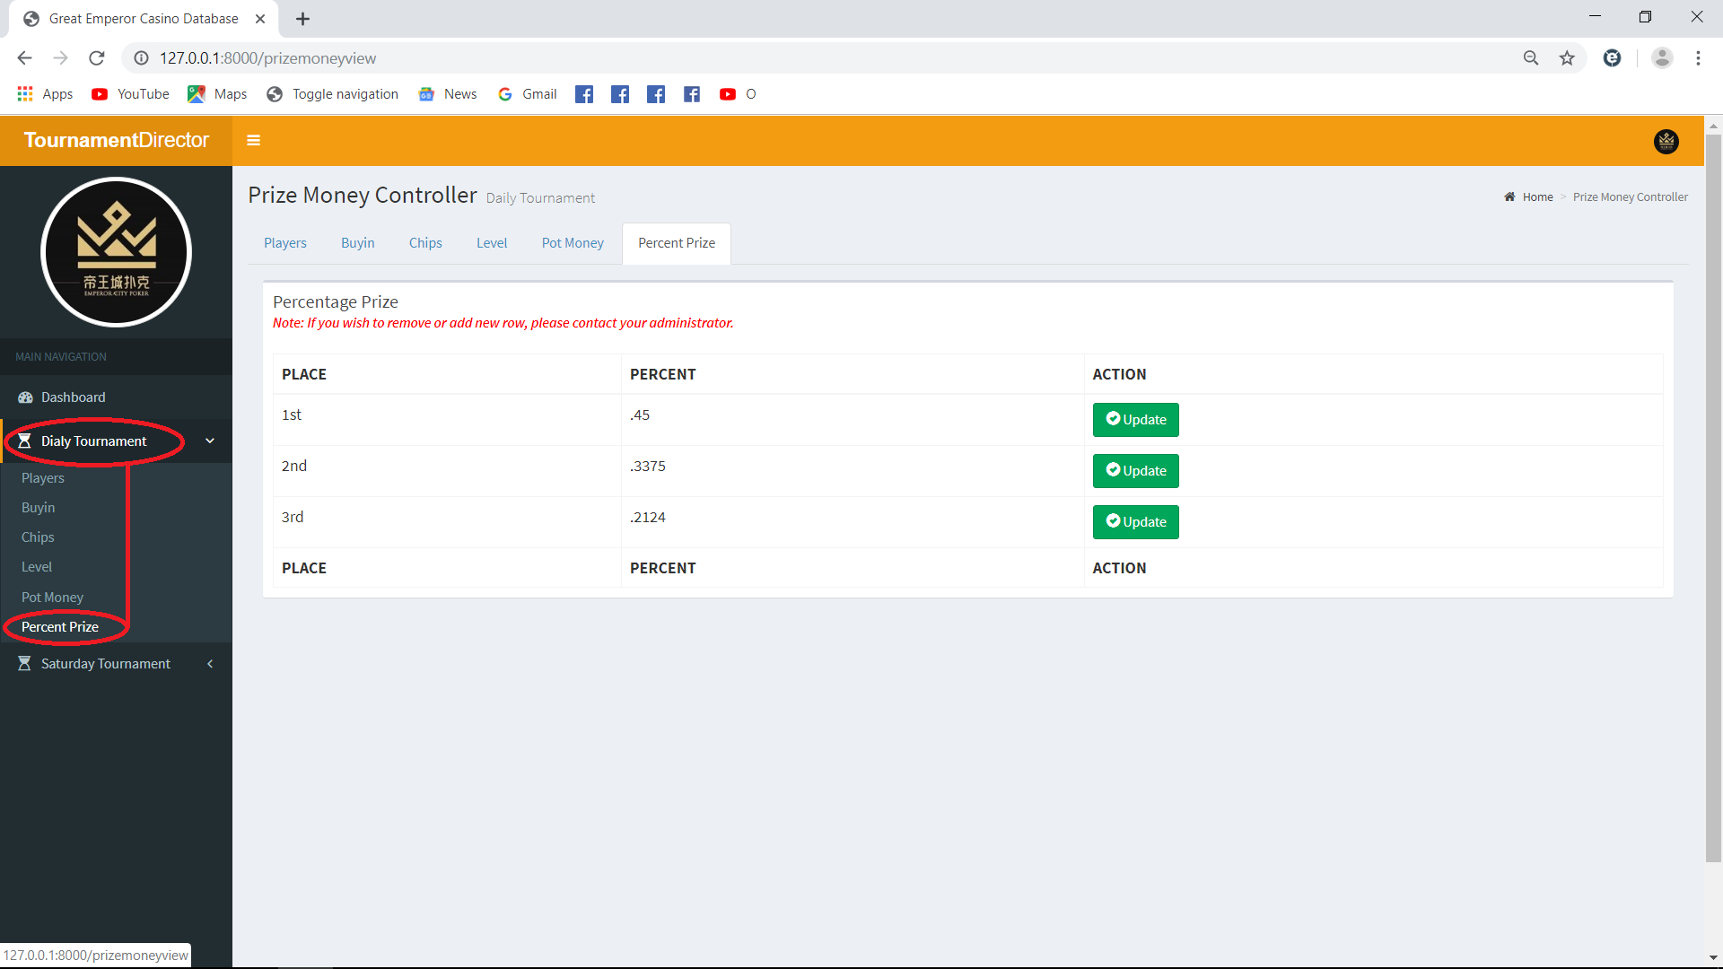Set Percentage Prize per Winner: Under Main Navigation, click “Daily Tournament” and click “Percent Prize”. Then click “Update” button if you wish to update the default data. A success message will appear once it is successfully updated. Kindly refer to the images bellow.

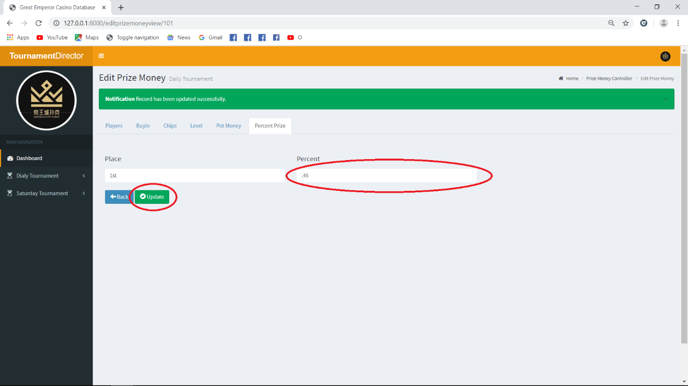***Note:*** *The rows in the Prize Money Controller are default. If you wish to delete or add a new row, kindly contact your administrator.*

1. 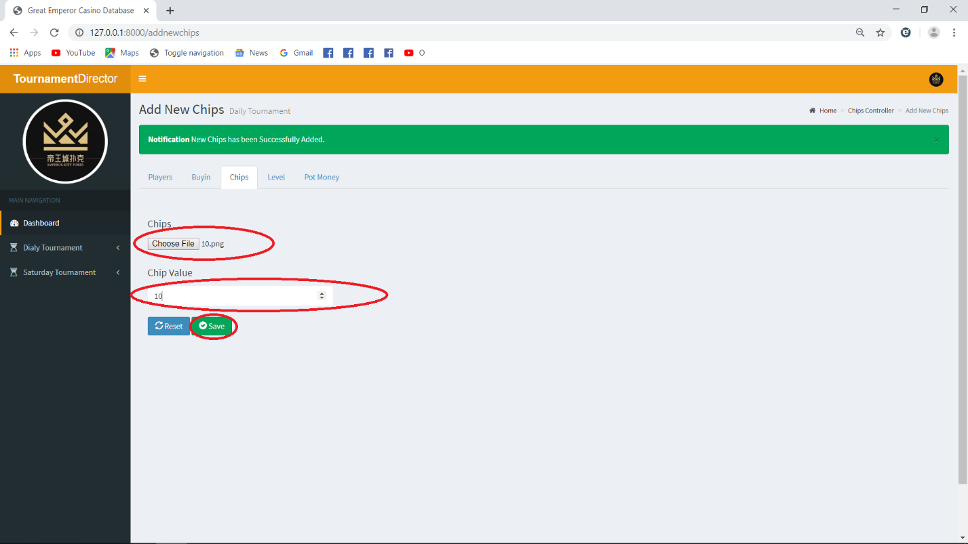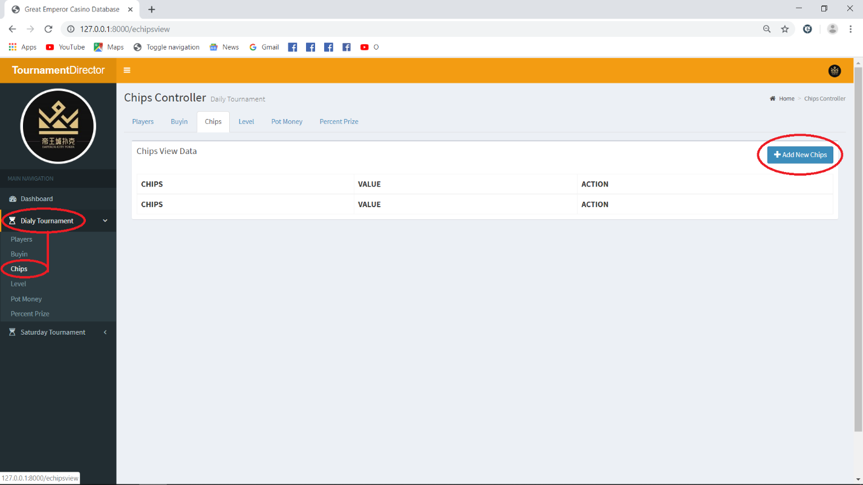Set Chips Value: Under Main Navigation, click “Daily Tournament” and click “Chips”. Then click “Add New Chips" choose the image of the chip you wish to be added and input its value. A success message will appear once it is successfully added. You can also update or delete a specific row if you wish to. Kindly refer to the images bellow.

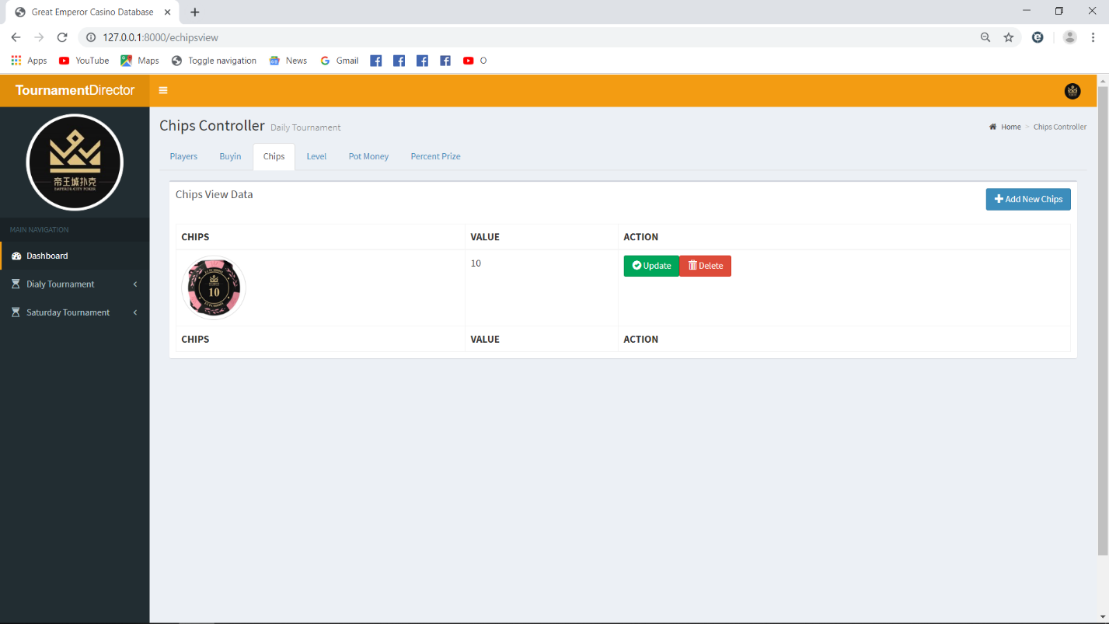

1. 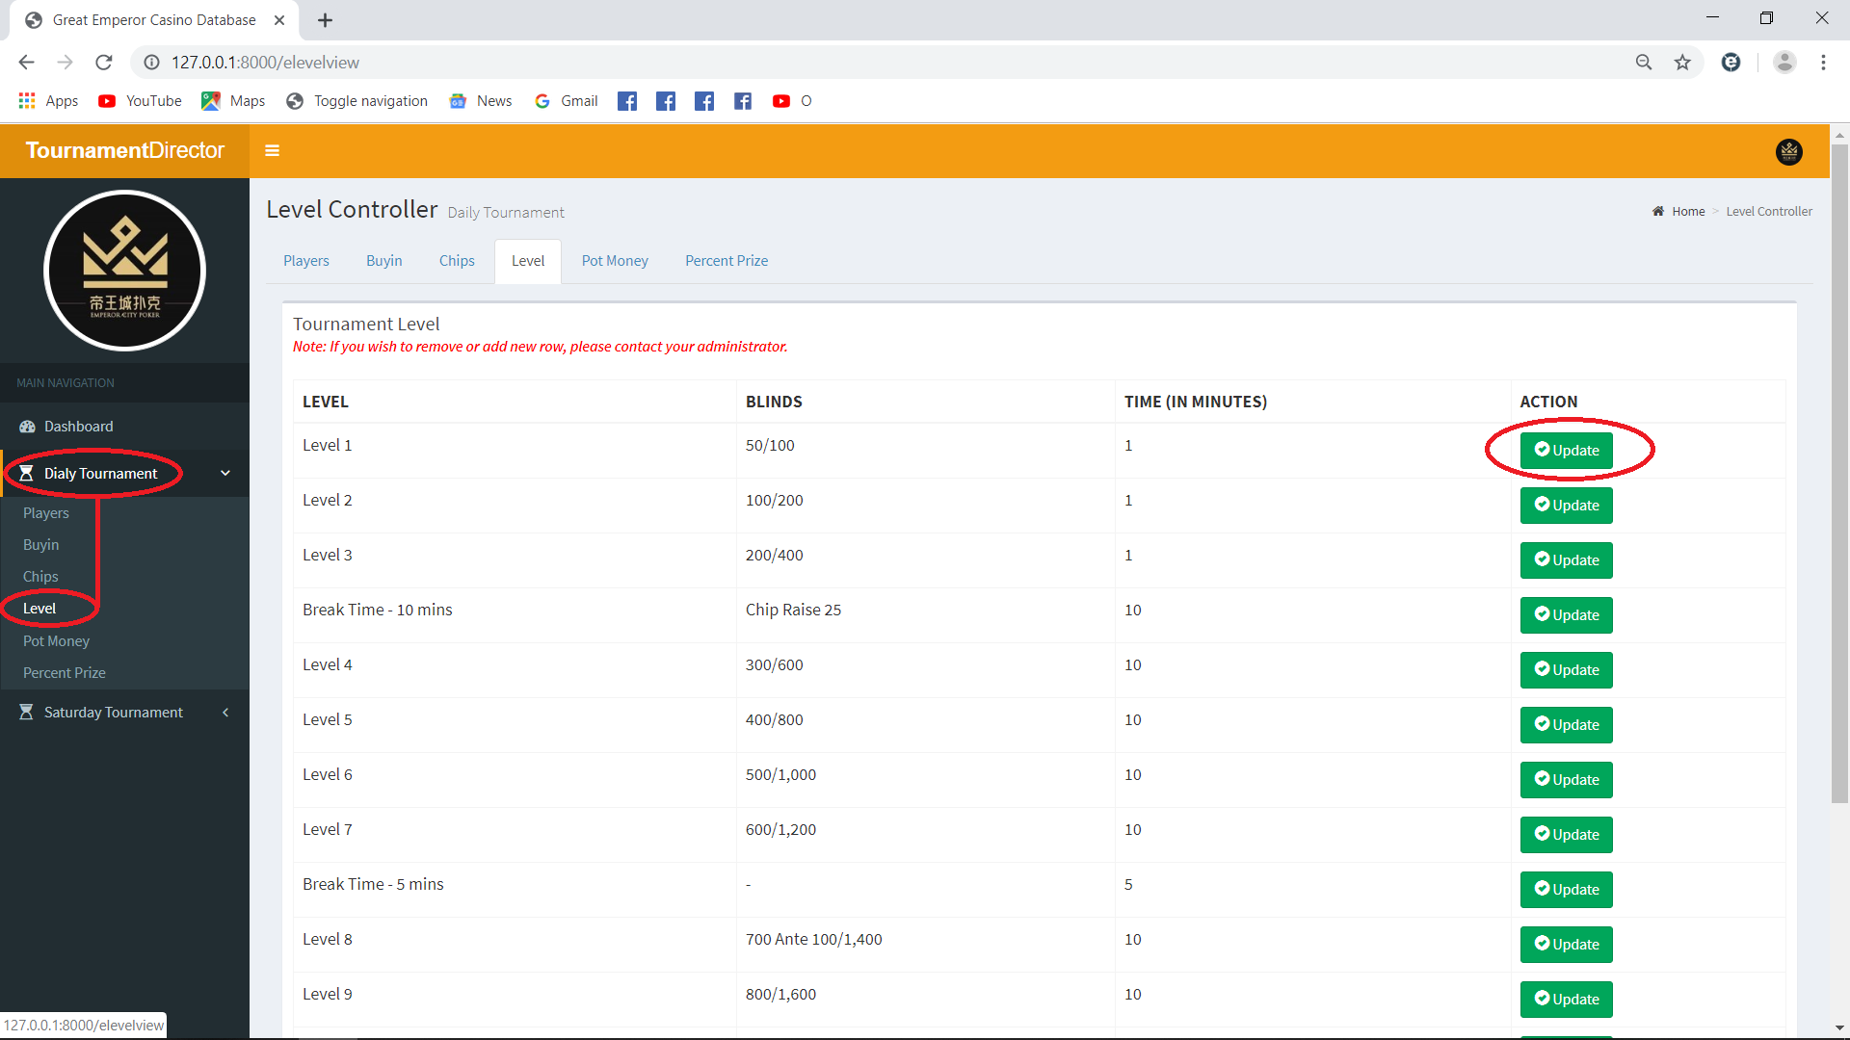Set Level/Round: Under Main Navigation, click “Daily Tournament” and click “Level”. Then click “Update” button if you wish to update the default data. A success message will appear once it is successfully updated. Kindly refer to the images bellow.

***Note:*** *The rows in the Level Controller are default. If you wish to delete or add a new row, kindly contact your administrator*

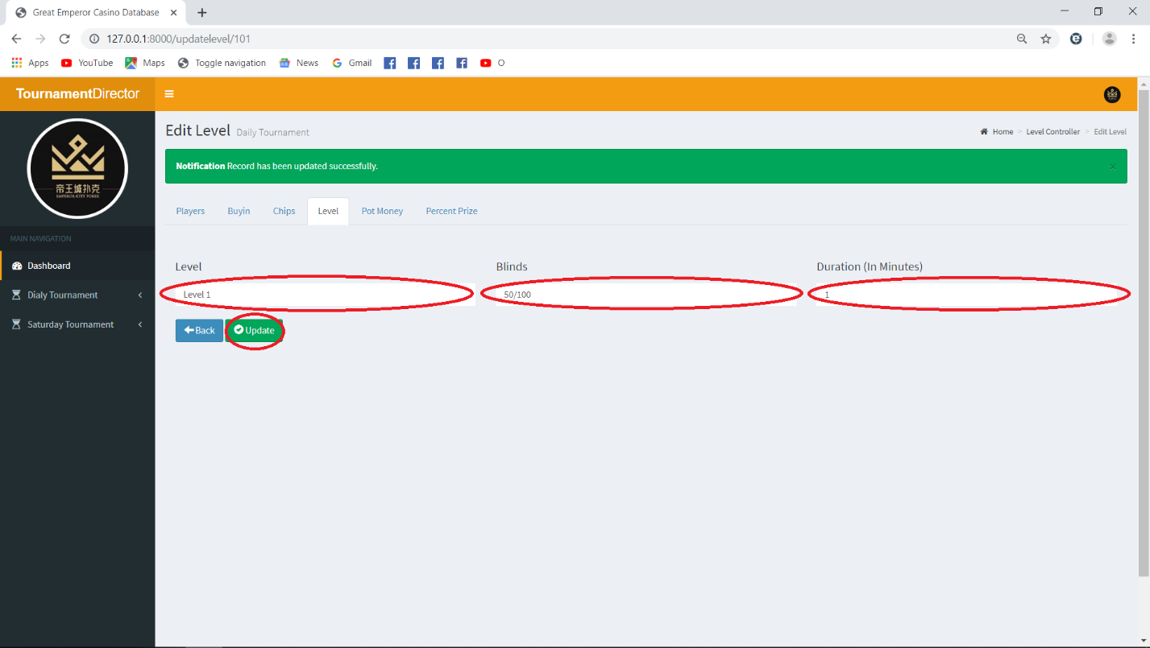

1. 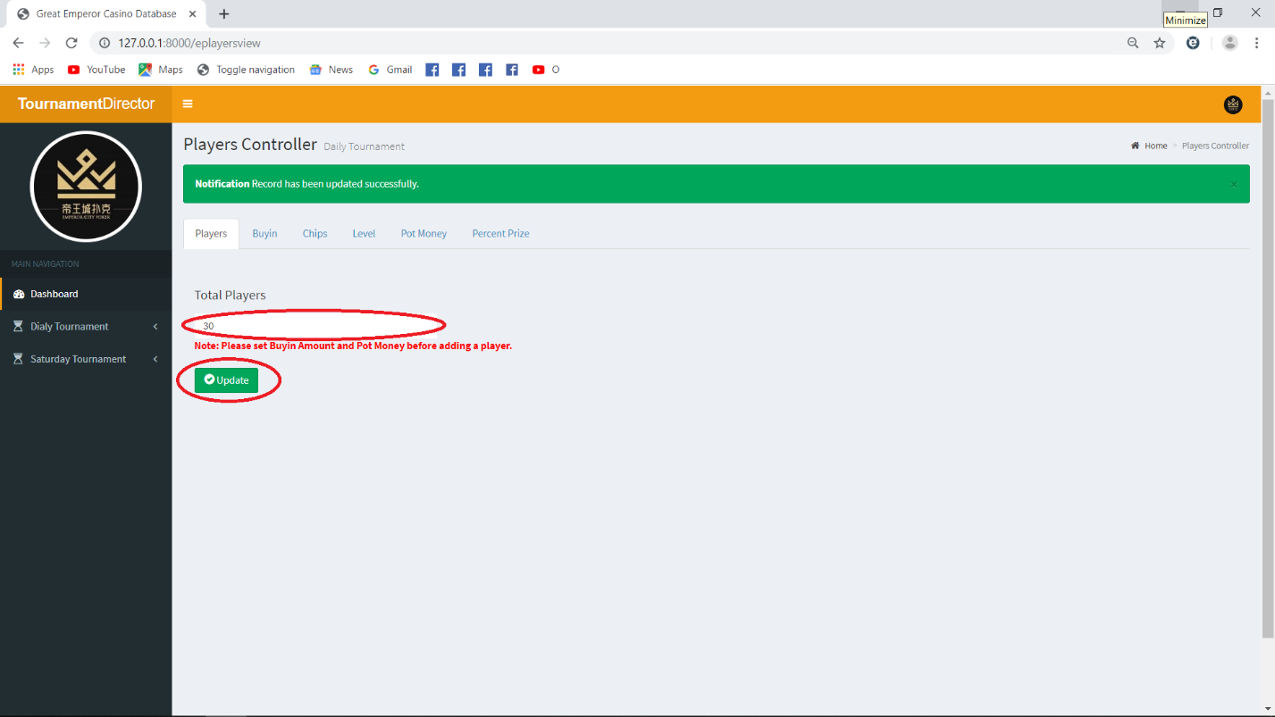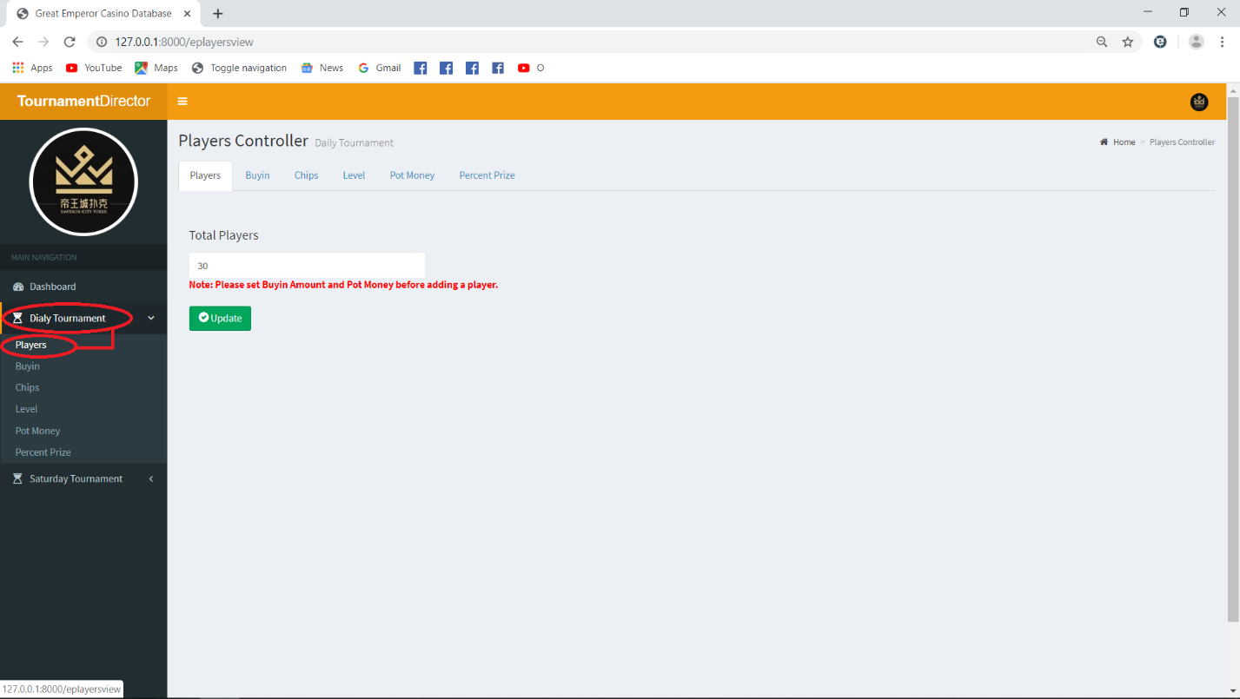Set Players: Under Main Navigation, click “Daily Tournament” and click “Players”. Then input the total number of players and click “Update” button. A success message will appear once it is successfully updated. Kindly refer to the images bellow.

***Note:*** *Please set “Buyin Amount” and “Pot Money” first before adding a player.*

1. 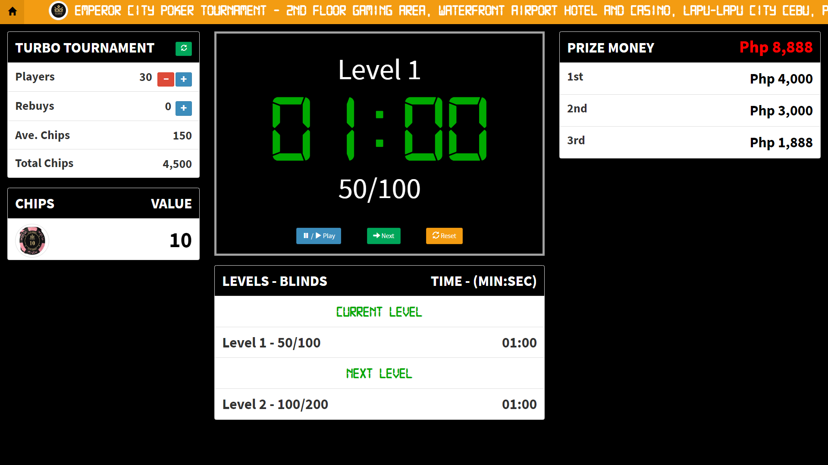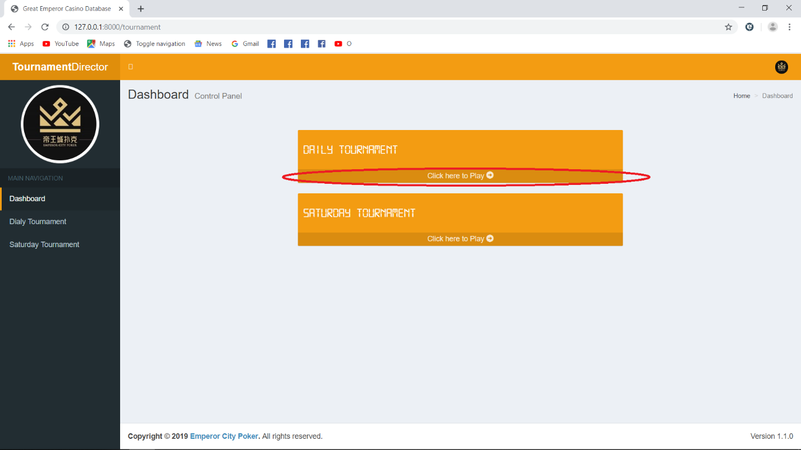Navigate to Main GUI of Daily Tournament: Under Dashboard click “click here to play” link bellow part of “Daily Tournament” small box. Please see attached images.
2. Saturday Tournament

This has the same procedure with “Daily Tournament”. Please refer to number “IV”.

1. Logout
2. 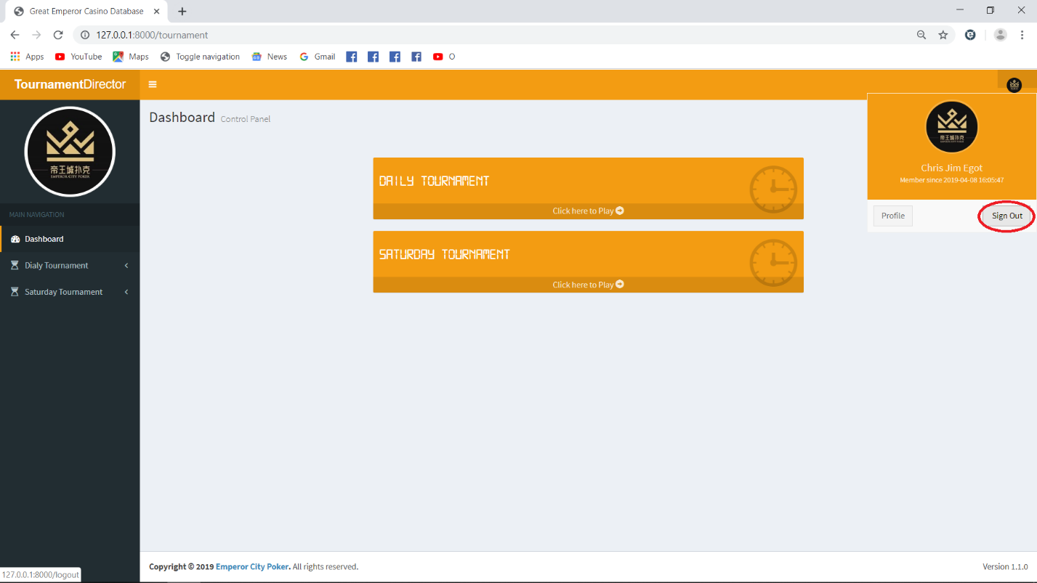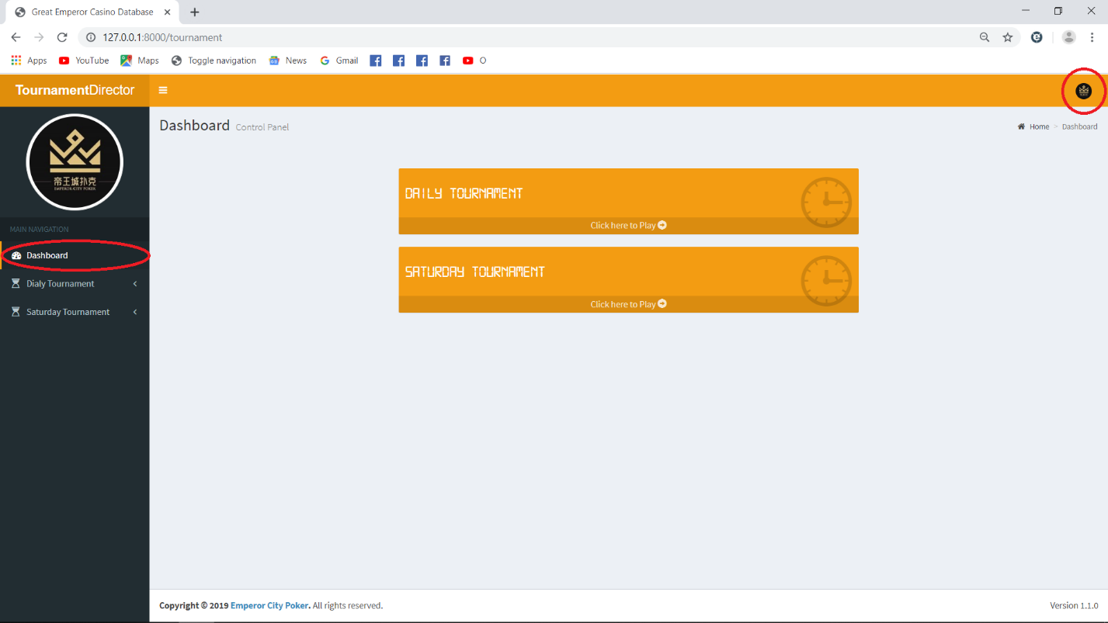Under Dashboard at the upper right corner you will see a small logo, click that and a small box will appear. Then click “Logout” button. Please see attached images bellow.